## Value

This integration will help us measure our performance towards reaching our retention goals while providing the best customer experience

## Inboxes that affect PD deals:

* 0_PRIORITY
* 0_TIER1
* 0_TIER2

## Time limit before a conversation goes stale

* (Non-CE opportunities) Conversations that have not been marked CEs – **10 days** to tag them as a PI to count as a success.
* (CE Opportunities) Opportunities that have been marked CEs – **10 days** to tag them as a CE-DO to count as a success.

## How conversations are classified:

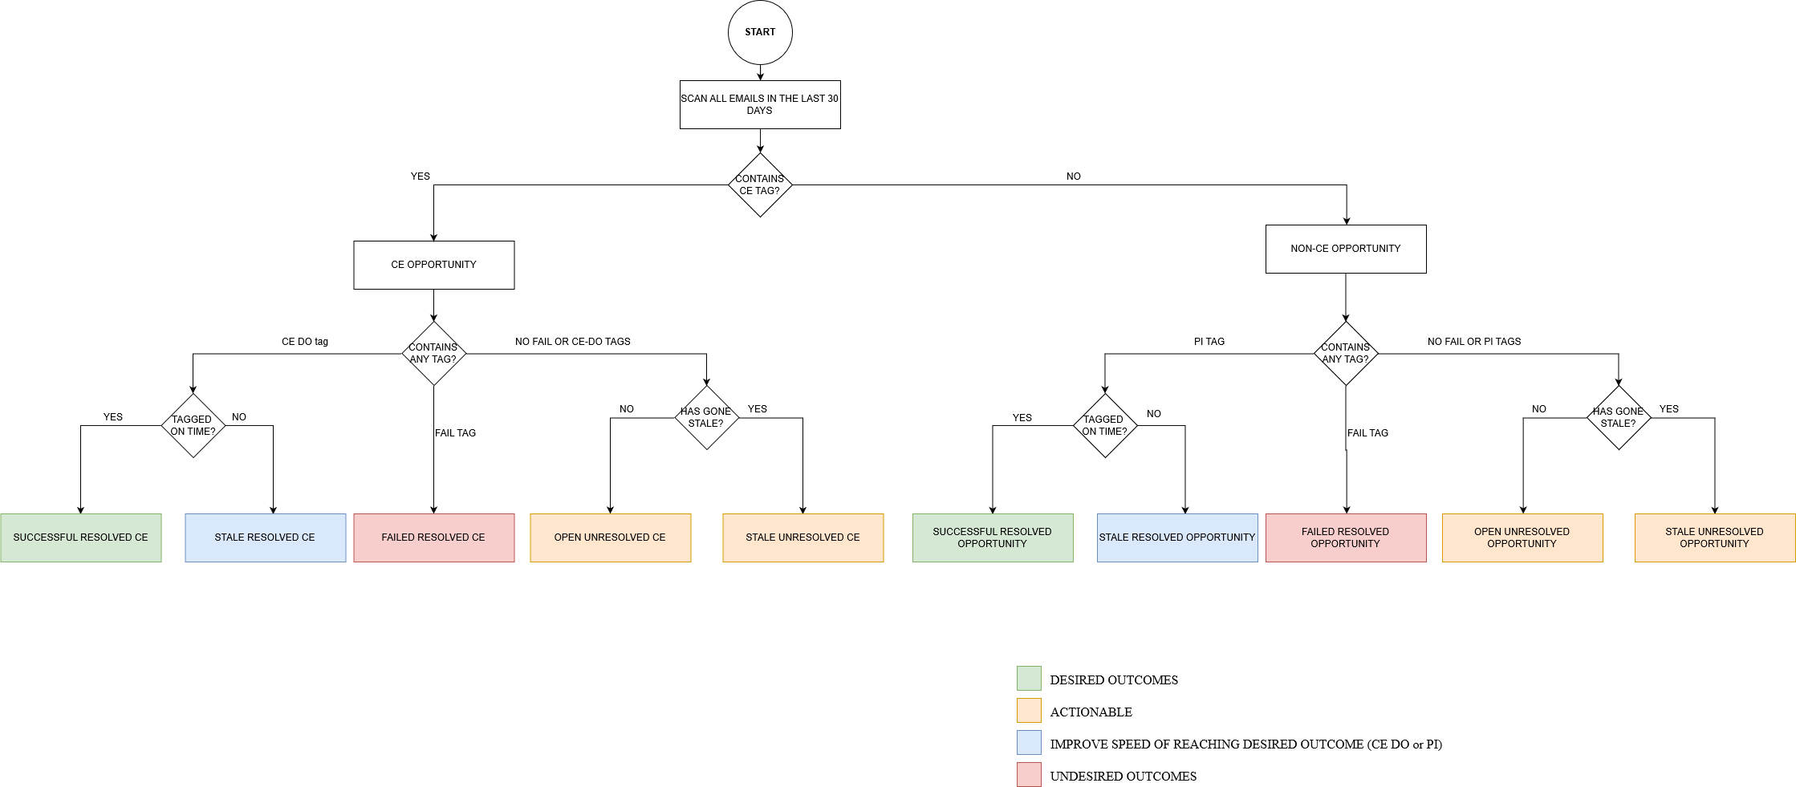

([Better resolution image](https://i.imgur.com/6p3r4bH.png))

* Unresolved opportunity (email conversation) if :
  + Either
    - Not tagged CE *and*
    - Not tagged PI *and*
    - Not tagged fail *and*
    - Irrespective of stale or not
  + Or
    - Tagged CE *and*
    - Not tagged CE DO *and*
    - Not tagged fail *and*
    - Irrespective of stale or not
* Resolved opportunity (email conversation) if:
  + Either
    - Not Tagged CE *and*
    - Tagged PI *or* fail
    - Irrespective of stale or not
  + Or
    - Tagged CE *and*
    - Tagged CE-DO or FAIL
    - Irrespective of stale or not

**Stale opportunities could be resolved or unresolved**

* Tagging PI to a stale conversation does not affect fields such as total PIs or last PI date. However, it does move the conversation from ‘stale unresolved opportunity’ to ‘stale resolved opportunity’. One of our goals is to have very few stale opportunities and even lower number of stale unresolved opportunities.
* Tagging a conversation as ‘fail’ works irrespective of whether the conversation is stale or not. It will affect metrics such as total failed opportunities etc. However, additionally, IF the deal has been stale, it will also move the conversation from total stale unresolved to stale resolved opportunities

## Meaning of PD fields and how they are updated

|  |  |  |
| --- | --- | --- |
| **Field** | **Meaning** | **How it’s updated** |
| Total Opportunities (30 days/ 1 Year) | Total email conversations we’ve had with the customers linked to this deal. This includes all CE and Non-CE opportunities (resolved or unresolved) | Counts all the emails from the selected emails |
| Stale Opportunity (30 Days/ 1 Year) | Total opportunities that went stale – does not matter if this conversation has been resolved or not. If a conversation is not resolved *before* going stale, it is counted here. | staleResolvedOpportunities (Non-CE) + staleUnresolvedOpportunities (Non-CE) |
| Total PI (30 days) | Total number of positive, on time (non-stale) interactions we have had. | successfulResolvedOpportunity |
| Total failed opportunities (30 days) | Total number of opportunities that have been marked failed. (Does not matter if before or after going stale) | totalFailedOpportuntities (Non-CE) |
| Total CE (30 days) | Total number of compelling events we’ve identified for this deal. | Count of conversations tagged CE |
| Stale CE (30 days) | Total number of CEs that were not marked CE-DOs or FAIL on time | staleResolvedCE + staleUnresolvedCE |
| Total CE DO (30 days) | Total number of CEs that were not marked CE-DOs on time | Count of conversations marked CE-DO within x days of marking them as CE (where x is the window we select) |
| Total failed CE (30 days) | Total number of CEs that were marked FAIL ever (before or after going stale) | totalFailedCe |
| Last open contact date | Date of conversation (opportunity) that has not been resolved yet – i.e. not marked PI or CE DO | Date of conversation (CE/Non CE) that has not been marked PI, CE-DO or fail |
| Last PI date | Last timely positive interaction | If no CE tag and PI tag within x days of conversation.dateCreated,  lastPIDate = pi.tagCreationDate  if the latter is more recent |
| Last open CE date | Last CE identified for the customers linked to this deal | If CE tag and not tagged CE-DO and not outside the x day window, update lastOpenCeDate =  conversation.creationDate  If the latter is more recent. |
| Last failed CE date | Date when we marked a conversation with people linked to this deal as FAIL (even if the conversation had gone stale) | If CE tag and fail tag, update lastFailedCE = fail_tag.creationDate  If latter is more recent |
| Last CE DO date | Date when we marked a conversation with people linked to this deal as CE-DO within x days of marking as CE | If CE tag and CE DO tag within x days of marking CE, lastCeDodate = cedo.tagCreationDate  If the latter is more recent |
| Currently open opportunities  Currently => actionable | Total Non-CE opportunities that are currently open and actionable (even if they have gone stale) | If no CE, PI or FAIL tag and conversation.creationDate is within x days, currentlyOpenOpportunities++ |
| Currently open CE | Total CEs that are currently open and actionable and not gone stale | If CE tag but no CE-DO or FAIL tag, and conversation.creationDate is within x days, currentlyOpenCEs++ |
| Currently stale opportunities | Total Non-CE opportunities that are actionable but have gone stale. | If no CE, PI or FAIL tag and conversation.creationDate is later than x days, currentlyStaleOpportunities++ |
| Currently stale CEs | Total CEs that are actionable but have gone stale | If CE tag but no CE-DO or FAIL tag and conversation.creationDate is more than x days,  currentlyStaleCEs++; |
| Contact history | Comma separated list of conversations (CE or Non-CE) that we have had with people linked to this deal | If today>deal.lastUpdate  contactHistory[today.Month]++; |
| PI history | Comma separated list of timely positive interactions that we have had with people linked to this deal | If PI tag and pi.tagCreationDate is within x days and if today>deal.lastUpdate,  piHistory[today.Month]++ |
| CE History | Comma separated list of Compelling Events that we have identified | If CE tag and today>deal.lastUpdate,  ceHistory[today.Month]++ |
| CE DO history | Comma separated list of timely successful resolution we have provided for the CE | If CE tag and CE-DO tag, and ce_do.tagCreationDate within x days of ce.tagCreationDate and  today>deal.lastUpdate ceDoHistory[today.Month]++ |

Discrepancies:

If you tagged something and it is not showing up on the dashboard, troubleshooting steps include

* Making sure that there is a PD Person account for that email ID AND that person account is linked to the deal